INDUSTRIAL PROPERTY FOR SALE

640 Norland Drive, Winkler

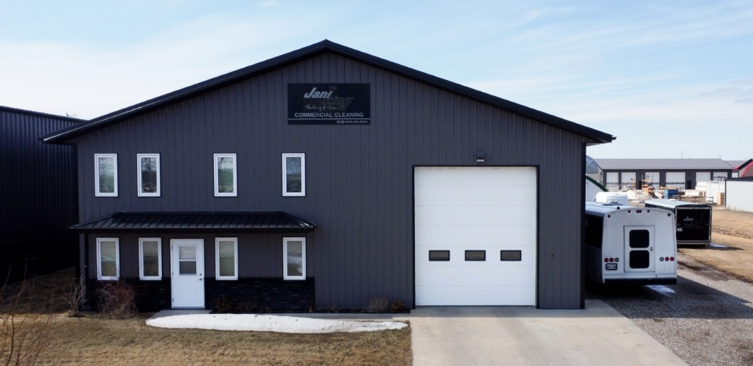
$779,900

3,560 sq ft

Built in 2016

Foundation – Concrete

Exterior – metal clad walls & roof

Taxes (2025): $11,203.21

Electric In-floor heat

HYDRO: $638/month

Zoning: Commercial

Lot Size: 108.04’ x 220.07’

Quick possession available

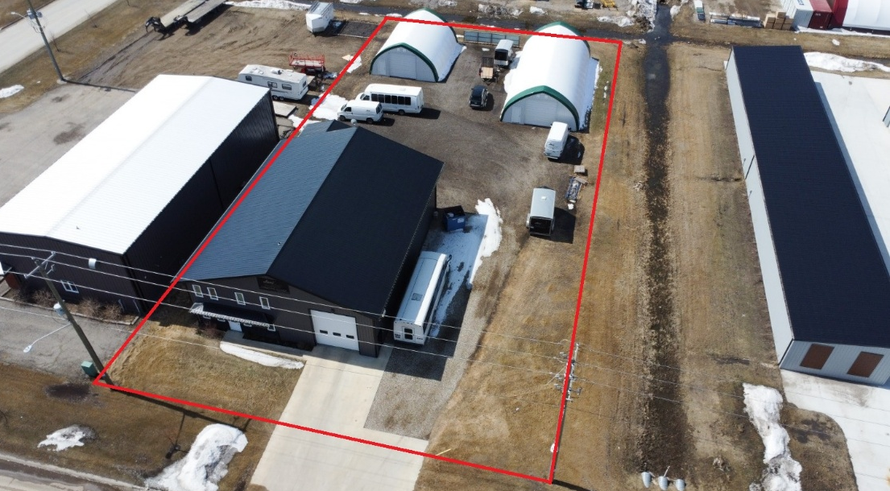

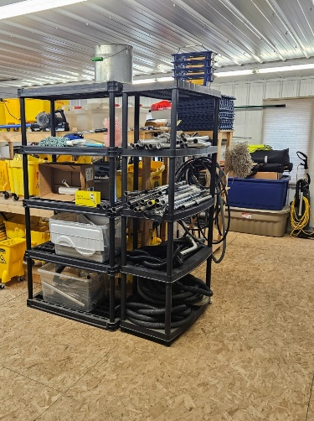
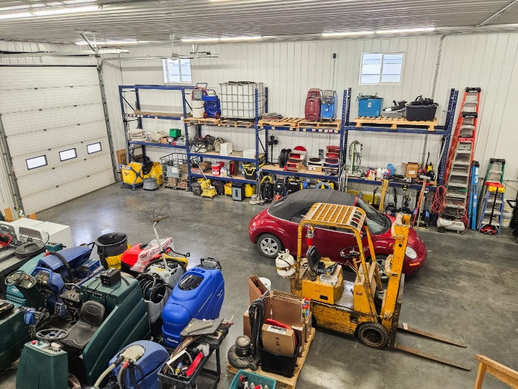

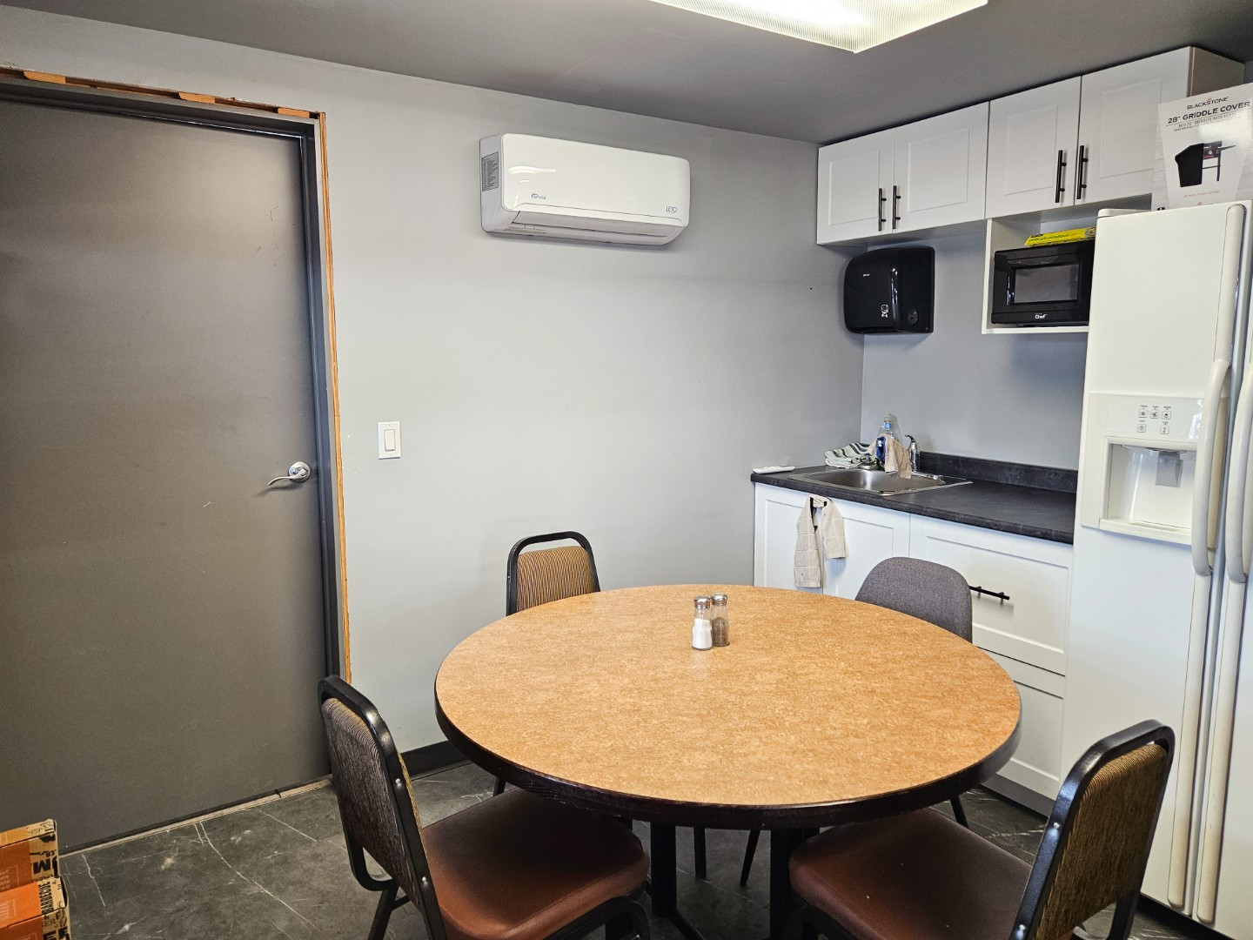

DETAILS

- 2 private offices
  - each measuring 9'6" x 10'
- Dedicated laundry/mechanical room
- 4 pc bath
- Two large 12' x 14' overhead doors
- Mezzanine space
- Separate 18' x 20' woodworking shop
- 200-amp breaker panel
- 220 welder plug
- 40-gallon electric hot water heater
- Electric in-floor heat throughout
- Two canvas shelters
  - One 30' x 40'
  - One 30' x 60'
  - Both equipped with 11'10” x 11' overhead doors & electricity

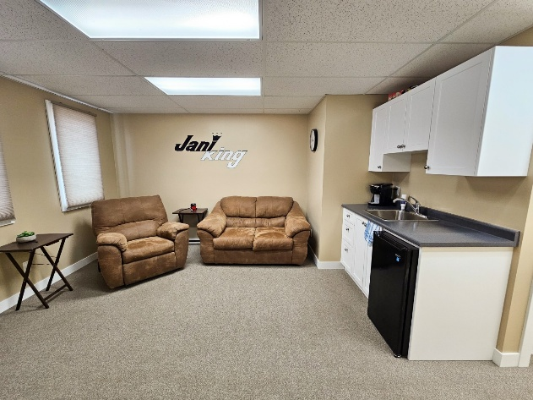
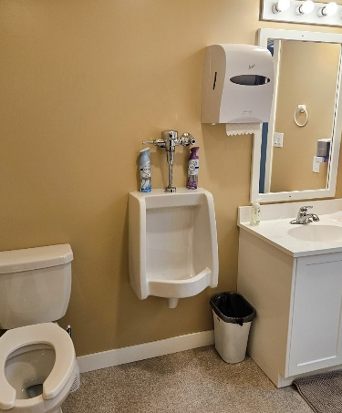
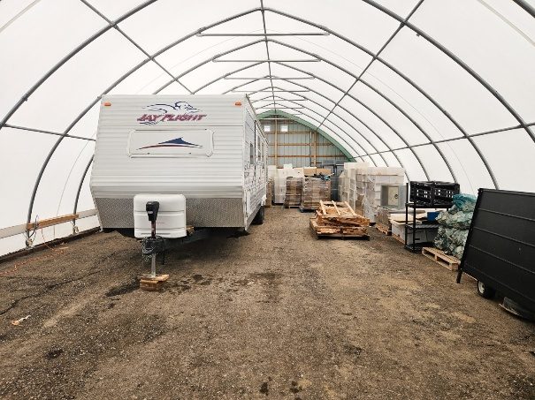
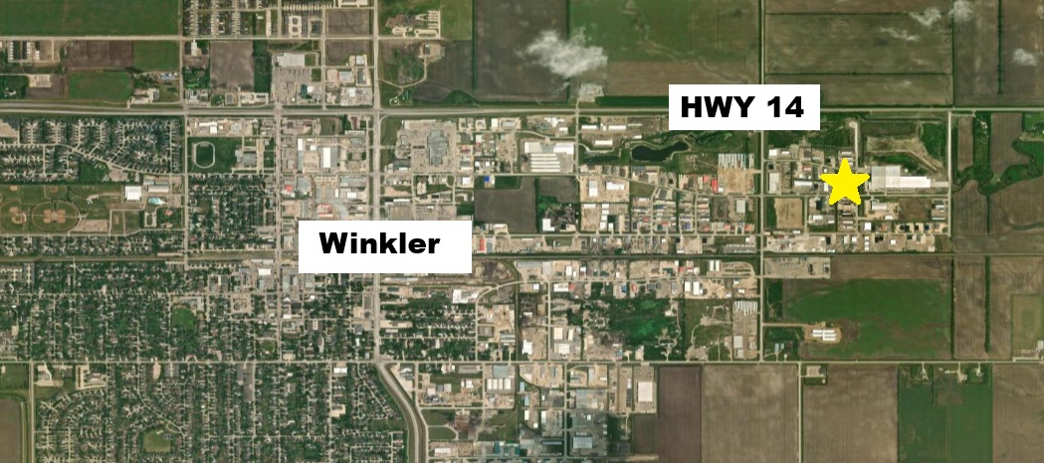
Note: current business is relocating
LOCATION

